Permit #
Date Received:

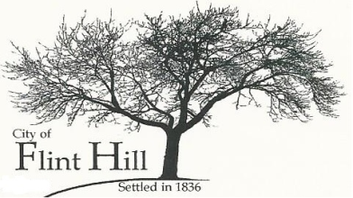
BILLBOARD/OUTDOOR ADVERTISING STRUCTURE
PERMIT APPLICATION
P.O. Box 196♦2061 Grothe Road♦Flint Hill, Missouri 63346♦(636) 327-4441 ♦ cityofflinthill@centurytel.net

APPLICANT:

ADDRESS:

PHONE: FAX:

LOCATION OF SIGN (ADDRESS):

PROPERTY OWNER: Name:

Address:

Phone: Fax:

LOCATION OF SIGN ON PROPERTY:

AREA OF SIGN FACE: ________________________________________________________________

LENGTH AND WIDTH OF SIGN FACE: __________________________________________________

HEIGHT OF TOP OF SIGN ABOVE GROUND:

HEIGHT OF TOP OF SIGN ABOVE STREET LEVEL: ______________________________________

ZONING OF THE PROPERTY:

SUPPLEMENTAL INFORMATION REQUIRED

A. Plans, to scale and approved by licensed engineer, providing construction and electrical details of sign and sign structure, including height and sign copy, in color.

B. State of Missouri Billboard Permit.

C. Site plan, to scale, containing:

- The proposed location of the sign upon the property.
- The distance from the proposed sign location to any buildings upon the property, and adjoining street right-of-way lines and driveway entrances.
- The distance from the proposed sign location to the next nearest billboard sign on the same side of the street in either direction.
- The distance from the proposed sign location to the nearest street in either direction.

FEE: DATE PAID: CHECK #

NOTE: This Application will be reviewed for decision only after this form is completed, the applicable fee is received, and such other requirements of applicable City ordinances are satisfied.

Applicant’s Signature Date

Owner’s Signature Date

Owner’s Signature Date

DATE SUBMITTED: _________________

PERMIT APPROVED BY:

Date

Any sign permit under which no construction work has been commenced within six months after the date of issuance of said permit or under which proposed construction has not been completed within one year of the time of issuance shall expire by limitation.

NOTE: By affixing signatures hereto, the Applicant and Owner hereby verify that: they have reviewed the applicable zoning and subdivision regulations; they are familiar with the specific requirements relative to this application; and they take full responsibility for this application. The above signatures further indicate that the information provided on this form and on any additional data attached hereto is true, complete, and accurate.

See Article 30 of the Zoning Ordinance of the City of Flint Hill.

