Permit #
Date Received:

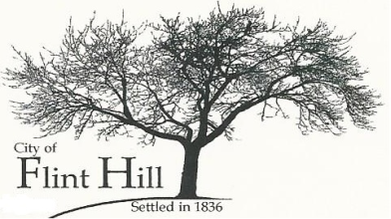
REZONING REQUEST
P.O. Box 196♦2061 Grothe Road♦Flint Hill, Missouri 63346♦(636) 327-4441 ♦ cityofflinthill@centurytel.net

APPLICANT:

ADDRESS:

PHONE: FAX:

LOCATION (ADDRESS):

PROPERTY OWNER: Name:

Address:

Phone: Fax:

LEGAL DESCRIPTION OF PROPERTY (other than address):

EXISTING ZONING: PROPOSED ZONING:

PROPOSED USE:

SUPPLEMENTAL INFORMATION REQUIRED:

A. Scaled map of the property, correlated with the legal description and clearly showing the location of the property.

B. The names and mailing addresses of property owners within an area determined by lines drawn parallel to and one hundred and eighty-five (185) feet distant from the boundaries of the district proposed to be changed, per the records on file in the Office of the St. Charles County Recorder of Deeds.

FEE: DATE PAID: CHECK #

NOTE: This Application will be reviewed for decision only after this form is completed, the applicable fee is received, and such other requirements of applicable City ordinances are satisfied.

Applicant’s Signature Date

Owner’s Signature Date

Owner’s Signature Date

DATE SUBMITTED: _________________

APPROVED BY:

Date

NOTE: By affixing signatures hereto, the Applicant and Owner hereby verify that: they have reviewed the applicable zoning and subdivision regulations; they are familiar with the specific requirements relative to this application; and they take full responsibility for this application. The above signatures further indicate that the information provided on this form and on any additional data attached hereto is true, complete, and accurate.

See Article 28 of the Zoning Ordinance of the City of Flint Hill.

