Permit #
Date Received:

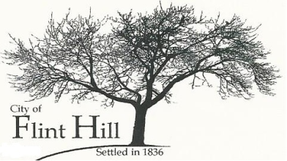
SEASONAL OR TEMPORARY USE PERMIT APPLICATION
P.O. Box 196♦2061 Grothe Road♦Flint Hill, Missouri 63346♦(636) 327-4441 ♦ cityofflinthill@centurytel.net

APPLICANT:

ADDRESS:

PHONE: FAX:

LOCATION OF SEASONAL OR TEMPORARY USE (ADDRESS):

PROPERTY OWNER: Name:

Address:

Phone: Fax:

TYPE OF SEASONAL OR TEMPORARY USE:

STRUCTURAL INFORMATION:

ELECTRICAL INFORMATION:

PARKING INFORMATION:

DURATION: starting ending

EXISTING ZONING:

SUPPLEMENTAL INFORMATION REQUIRED

A. Drawing showing the location and layout of the seasonal or temporary use.

FIREWORKS STANDS OR TENTS ALSO REQUIRE THE FOLLOWING:

A. A site plan, drawn to scale, showing all permanent and temporary structures on the property, parking areas, storage areas, dimensions of the property and location of all structures including the distances from property lines and between structures.
B. A letter from the owner of the property on which the stand or tent is located authorizing the use and any structure on the property, and dated and notarized not earlier than sixty (60) days prior to the date of the application.

C. At least five (5) off-street parking spaces which are not located on vegetated areas.

D. A certificate of insurance showing the following coverage levels and showing the City of Flint Hill as additionally insured:

Injury Including Death $1,000,000.00 one person
$2,000,000.00 more than one person
Property Damage $1,000,000.00 each occurrence
$1,000,000.00 aggregate

FEE: DATE PAID: CHECK #:

NOTE: This Application will be reviewed for decision only after this form is completed, the applicable fee is received, and such other requirements of applicable City ordinances are satisfied.

Applicant’s Signature Date

Owner’s Signature Date

Owner’s Signature Date

DATE SUBMITTED: _________________

PERMIT APPROVED BY:

Date

NOTE: By affixing signatures hereto, the Applicant and Owner hereby verify that: they have reviewed the applicable zoning and subdivision regulations; they are familiar with the specific requirements relative to this application; and they take full responsibility for this application. The above signatures further indicate that the information provided on this form and on any additional data attached hereto is true, complete, and accurate.

See Section 18.08 of the Zoning Ordinance of the City of Flint Hill.

